Linux Networking Basic

TCP/IP Protocol

TCP (Transmission Control Protocol)

TCP/IP is the most popular networking protocol suite, is often referred to as a protocols, actually it's made up from several protocols. TCP and IP protocols, in addition there is also a third, named UDP.

1. TCP is responsible for breaking down network transmission into sequences (Packet and segment) which are sent to the target node and reassembled back into the original message.

2. TCP performs a three-way handshake, when setting up connection.

3. The first packet, SYN (synchronize), is sent to the receiver, that it wants to start a communication.

4. Once packet is received at the receiving end, a SYN/ACK (synchronize/acknowledge) packet is sent back to the sender.

5. Finally, an ACK (acknowledge) packet is sent to the receiver, and connection is established and the nods are able to communicate.

6. TCP has built-in features to deal with error, error correction ensure that a packet was received the same as, that was sent.

7. TCP packets contain a checksum and algorithm to verify it, if verification is fails, the packet is then discarded.

8. The flow controls feature in TCP handles the speed at which data is transferred. A transmission speed as fast as its slowest point in the path between two nodes.

9. Flow controls process is known as a sliding window, at receiving end receive window, which tells the sender that how much data it's able to receive.

Internet Protocol (IP)

The IP (Internet Protocol) actually sending and receiving of the packets that TCP wants to send or receive. In each packet, there is a source and destination known as an IP address, each connected node has a network interface with its own unique IP address. IP protocol use IP address to figure out where a packet needs to go. TCP splits up a communication and IP route them to their destination.

User Datagram Protocol (UDP)

UDP is also a part of TCP/IP suite as well. It’s very similar to TCP, the main difference is that UDP is connection-less. This means that UDP does not verify anything. It sends the packets, but does not guarantee delivery. If a packet isn't received by the target, it will not be resent.

Hostname Resolution
In a network, remembering the IP address is difficult, rather than using name to IP resolution is more convenient to look up a device. A device (host/node) is required to know the IP address of another host to communicate. If you typed in a name instead of an IP address, the machine will attempt hostname resolution, if a valid entry in Domain Name System (DNS) is present for that node, you’ll communicate. By default, DNS is not the first place that a Linux host will look in order to resolve hostnames. There is also a file saved locally on the system (/etc/hosts) that your machine will check first. You could create additional name to IP address matches within this file. For example, if a computer had named debian and IP address 10.10.96.10, you could add it to the end of the hosts file as follows:
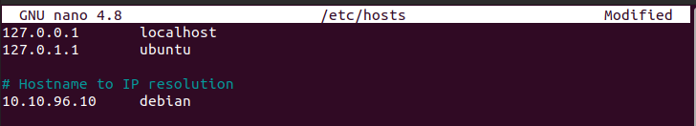
Now, you'd be able to ping/reach IP address 10.10.96.10 by typing in debian. While hosts file is checked first, in Linux a file, /etc/nsswitch.conf, check the host resolution order on your machine with the following command:
cat /etc/nsswitch.conf | grep hosts
You'll get the following output:
hosts: files mdns4_minimal [NOTFOUND=return] dns
Here, we can see the system is set up to check files first, which represents local files.

